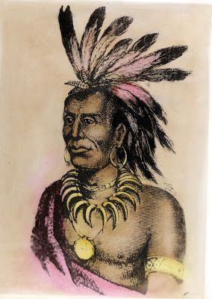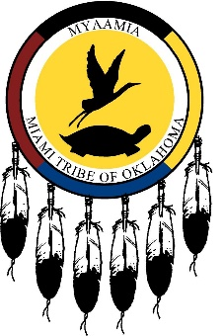

Ty Marking

Period 2

The Miami Tribe

In the past…

Prehistory

Mainly Mississippian society. Grew maize and organized under a chiefdom along the western shore of Lake Michigan due to pressure from the Iroquois to the East.

Mid-17th century

First contact with Europeans by French missionaries

Mid-17th to mid-18th century

The Miami people migrated from Wisconsin to northwest Ohio on the Wabash river.

1704

Allowed French to establish the first trading post at Kekionga

Late 18th century

Chief Little Turtle joined many Miami bands and other tribes to fight against the Europeans and the westerly advancing settlers.

1810

Little Turtle repels attacks on the Miami capital and stages the largest defeat of an American Army by Native American forces.

1826

The town of Prophetstown is destroyed under the pretext of the War of 1812. Many more villages are attacked.

1826

Treaty of Mississinwas forced the Miami to cede most of their land to the US

1846

Most of the Miami are forced to the west eventually to Oklahoma under the Indian Removal Act

To Current

Western Miami are recognized by the federal government although the eastern remnants are not federally recognized

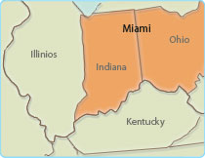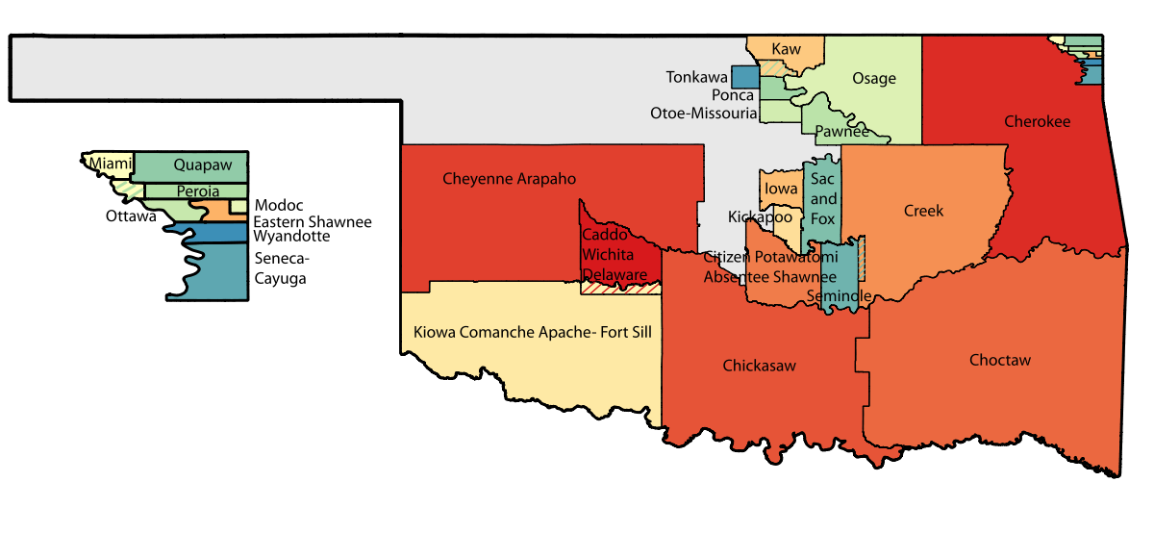

Location

Interesting Facts

1. In their traditional language the Miami peoples name means “downstream people”
2. The word “Miami” comes from the Miami word for “allies”
3. The Sandhill is their sacred bird
4. The Miami tribe and Miami beach have no relation.
5. Used controlled fires to drive buffalo towards hunters
6. Had extensive trade networks
7. Chicago was originally a Miami village

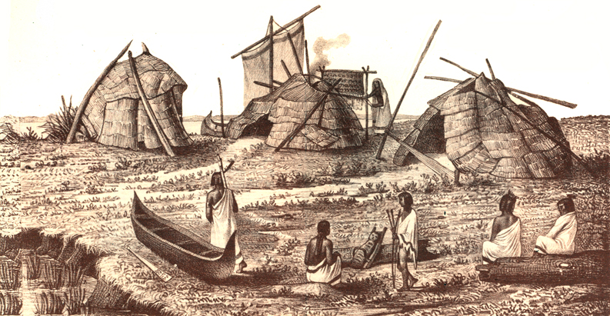

Background

The Miami tribe ancestrally occupied present day western Ohio and parts of eastern Indiana. Their language was an Algonquian language as most of the north-western tribes’ languages are. However, this traditional language is lost to the ages.

The Miami lived in villages in small oval houses constructed over reeds that had been weaved together. Most villages also had a central house that held council meetings. They found food by both hunting and farming mainly maize.

The Miami tribe had two chiefs, one was elected by village leaders and governed the villages. The other was a war chief elected by warriors to lead to the tribe to victory. The Iroquois forced many of the Miami to move west to the western shore of Lake Michigan, but the Miami reclaimed their homeland in mid-17th to mid-18th century. When the Europeans arrived, the Miami had good relations with the French until they were pushed out in the French Indian war.

The Miami had Shamans who

would wield supernatural power,

often against each other in contests

of strength. They gained their

power from spirits called manitous

contacted in dreams.

The Miami were forced from most of Ohio and Indiana to this small part of Oklahoma